10-11-24

When accessed VS code (code .), got the following msg:

How to edit Supplementary files? This is what I see:

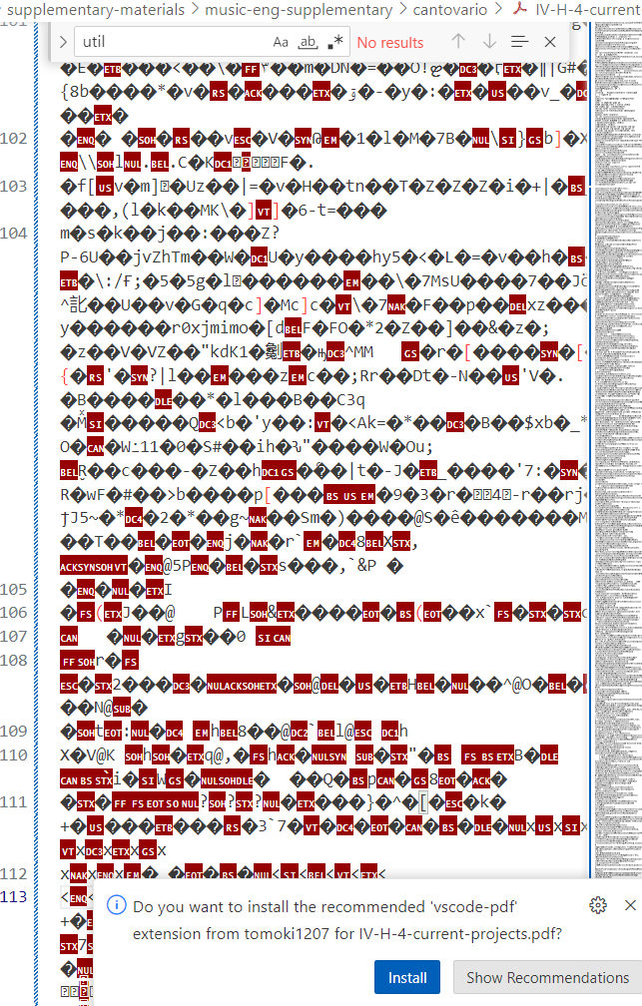

10-10-24

Links that don't work:

<http://127.0.0.1:5501/music-subpages/musical-works.html>

Under PLDM - The scores for all these performances can be found [here.](http://127.0.0.1:5501/website-documents/supplementary-materials/music-supplementary/III-G-musical-scores-commissions.pdf)

VS code:

 <p>The scores for all these performances can be found

<a

href="../website-documents/supplementary-materials/music-supplementary/III-G-musical-scores-commissions.pdf"

target="_blank">here.</a></p>

I'm using ctrl / to comment out text not directly relevant to the ws.

How to insert a line break?

<p>Four large projects comprise this section.

I used

<p></p>

How to unbold text:

</b>

three overarching themes of lifelong learning, intrinsic motivation, and the creative process

I finished musical-works.html

How do i navigate in vs code from the home page to each succeeding page, in order, until the end?

Where do i find the supplementary materials to edit, e.g., adding new patents

steps:

CTRL+S to save your file before pushing.

To do this, first type git add . to add all of the modified files to what you’ll push. Press Enter.

Then, type git status to check if all of your changes have been added to the staging.

 type git commit -m ‘type commit message here’

Once your commits have been staged, you want to finally push them to the main branch. To do this, type git push

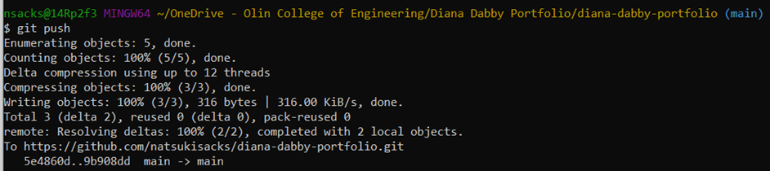

It shd look someth like the above.

If you’ve successfully pushed, the main repo should reflect that it’s been updated! You can check that [here:](https://github.com/natsukisacks/diana-dabby-portfolio) <https://github.com/natsukisacks/diana-dabby-portfolio>